|  |  |  |  |  |  |  |
| --- | --- | --- | --- | --- | --- | --- |
| VILNIAUS KOLEGIJA  UNIVERSITY OF APPLIED SCIENCES  FACULTY OF ELECTRONICS AND INFORMATICS  Image result for viko logo | | |  | | | VILNIUS COLLEGE  Image result for viko logoFACULTY OF ELECTRONICS AND INFORMATICS |
|  | | |  | | |  |
| **INTRODUCTION TO INFORMATICS** | | |  | | | **INTRODUCTION TO INFORMATICS** |
| PRACTICAL ASSIGNMENT  SPOTIFY USER GUIDE  6531BX028 PI18E | | |  | | | PRACTICAL ASSIGNMENT  SPOTIFY USER MANUAL  6531BX028 PI18E |
| STUDENT | DŽIUGAS PEČIULEVIČIUS | STUDENT | | DŽIUGAS PEČIULEVIČIUS |
| (SIGNATURE)  10/17/2018 | | |  | | | LECTURER |
| LECTURER | VIRGILIJUS KUKLIERIUS | (SIGNATURE)  10/17/2018 | | VIRGILIJUS KUKLIERIUS |
| (SIGNATURE)  10/17/2018 | | |  | | | 2018 |
| 2018 | | |  | | |  |

**CONTENTS**

WHAT IS SPOTIFY? 3

**Can I burn CDs in Spotify?** 3

DOWNLOAD THE APP 4

**Desktop** 4

**Mobile and tablet** 5

GETTING STARTED 6

**Create an account** 6

**Get the app** 6

WEB PLAYER 7

YOUR LIBRARY 8

**Where is Your Library?** 8

**How do I save to Your Library?** 8

Got Premium? 8

HOW TO PLAY 9

To play great music, podcasts, and more on Spotify, all you need is the app, or go to our web player. 9

**Desktop** 9

**Mobile & Tablet** 9

**Control your listening with Now Playing** 9

Resources 11

**Pic 1 – Download page** 5

**Pic 2 – Run your setup** 5

**Pic 3 – Wait for the installer to finish** 6

**Pic 4 – Allow Spotify on your FireWall** 6

**Pic 5 – Enjoy!** 6

**Pic 6 – Home page example** 8

# WHAT IS SPOTIFY?

Spotify is a digital music, podcast, and video streaming service that gives you access to millions of songs and other content from artists all over the world.

Basic functions such as playing music are totally free, but you can also choose to upgrade to Spotify Premium. Either way, you can:

* Choose what you want to listen to with **Browse** and Search.
* Get recommendations from personalized features, such as Discover Weekly, Release Radar, and Daily Mix.
* Build collections of music.
* See what friends, artists, and celebrities listen to.
* Create your own Radio stations.

Spotify is available across a range of devices, including computers, phones, tablets, speakers, TVs, and cars, and you can easily transition from one to another with Spotify Connect.

## **Can I burn CDs in Spotify?**

Spotify is a streaming service only. Our licensing means there's no way to export our content outside of the app.

# DOWNLOAD THE APP

The app is totally free to download, and there’s no cost for basic features such as playing music.

Learn how to download Spotify for each device below.

**Tip:** New to Spotify? Check out [**our guide to getting started**](https://support.spotify.com/using_spotify/search_play/getting-started/).

## **Desktop**

1. Go to [**www.spotify.com/download**](http://www.spotify.com/download). If your download doesn't start within seconds, click **restart the download**.

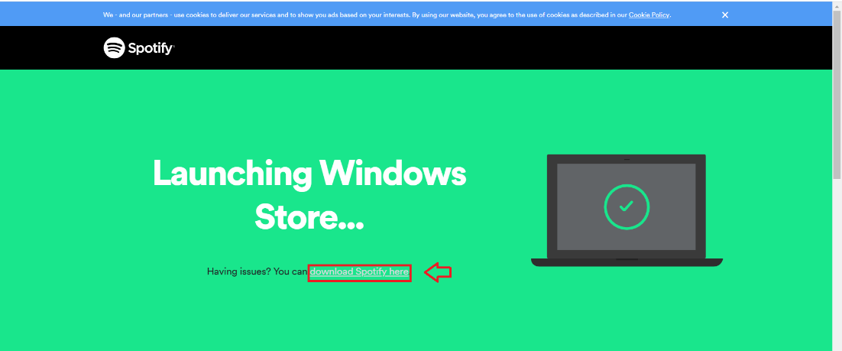

**Pic 1 – Download page**

1. Look for the app in your **Downloads** folder and double-click it.

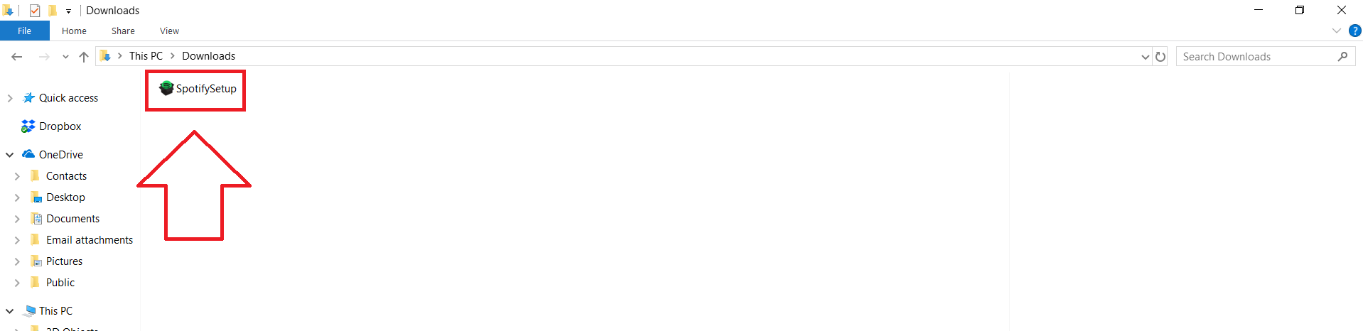

**Pic 2 – Run your setup**

1. Continue through the installation steps.

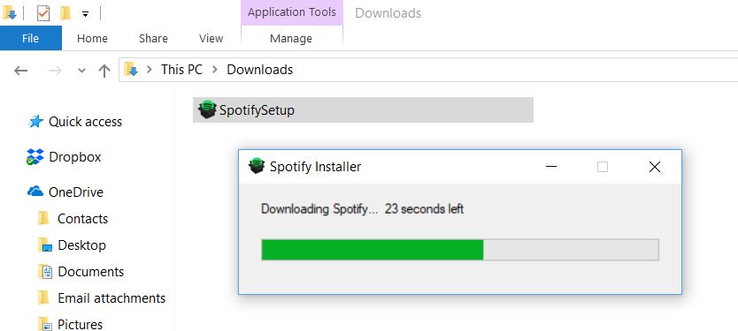

**Pic 3 – Wait for the installer to finish**

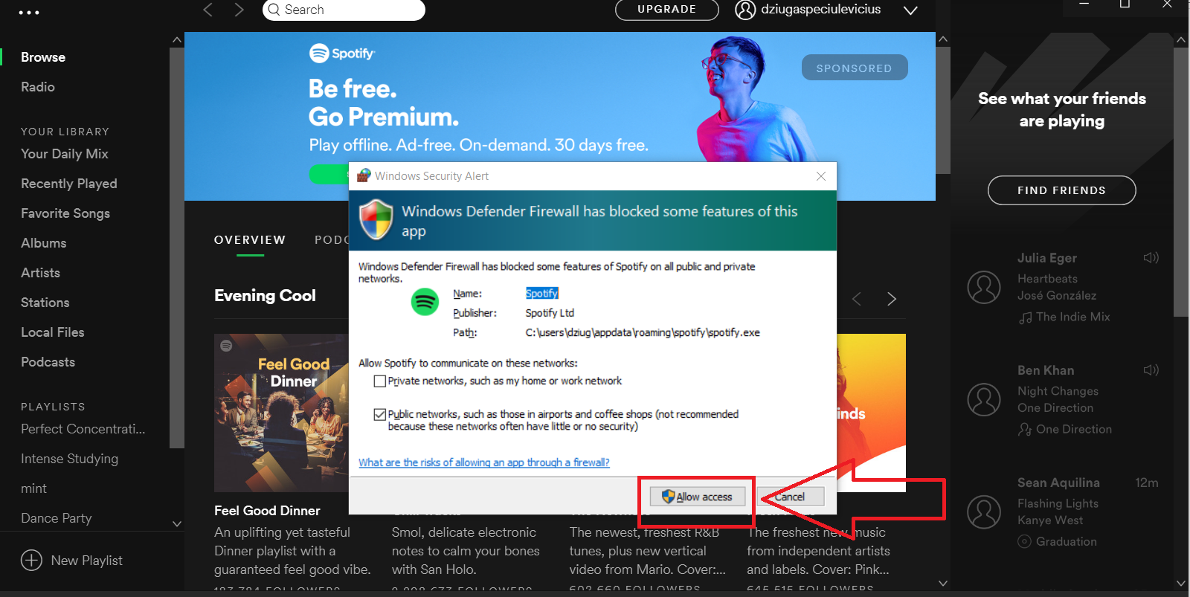

**Pic 4 – Allow Spotify on your FireWall**

1. Log in and enjoy the music!

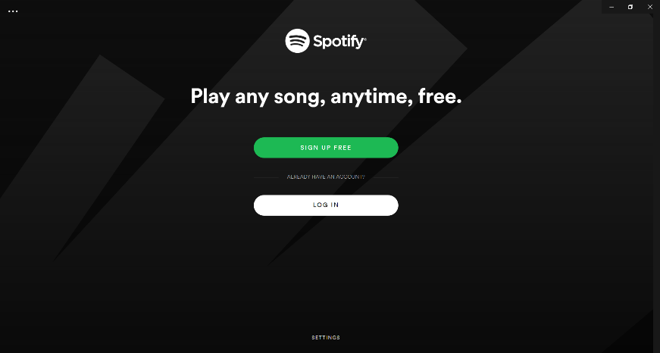

**Pic 5 – Enjoy!**

If you're unable to download the app, you can play music from your browser using our [**web player**](http://play.spotify.com/).

## **Mobile and tablet**

To listen to music on the go, download Spotify from the Google Play or Apple app store.

[**Spotify on Android with Google Play**](https://play.google.com/store/apps/details?id=com.spotify.music)  
[**Spotify on iOS with the AppStore**](https://itunes.apple.com/app/spotify-music/id324684580?mt=8)

# GETTING STARTED

Here’s all you need to know to get started with Spotify.

## **Create an account**

The first step is to pick one of the following ways to create a free account with us. For additional features, you can then subscribe to [**Premium**](http://www.spotify.com/premium).

**With your email address**

1. Go to our [**sign up page**](http://spotify.com/signup).
2. Enter your email address and choose a password.
3. Fill out the other details.
4. Click **SIGN UP**.

**With Facebook**

1. Go to our [**sign up page**](http://spotify.com/signup).
2. Click **SIGN UP WITH FACEBOOK**.
3. Enter your Facebook login details and click **LOG IN**.  
   **Note:** Your device may automatically recognize and use any accounts that are already logged in to Facebook.

Check out information about [**using Spotify with Facebook**](https://support.spotify.com/account_payment_help/account_basics/using-spotify-with-facebook/).

**Tip:** To keep all your music and subscriptions in one place, we recommend not creating more than one account. Check out our guide to [**finding any accounts you already have**](https://support.spotify.com/account_payment_help/troubleshooting/do-i-have-an-additional-account/).

## **Get the app**

Now that you’ve created an account, [**download Spotify for free**](http://support.spotify.com/listen_everywhere/on_phone_tablet_desktop/download-the-spotify-player/).

The app is available on desktop, mobile, tablet, TV, and in the car. You can have it on as many devices as you like.

Or, if you don't want to download the app, go to our [**web player**](http://play.spotify.com/) to start listening straight away from your browser.

# WEB PLAYER

Along with our desktop, mobile, and tablet apps, you can play Spotify from the comfort of your browser on our [**web player**](http://play.spotify.com/).

You can access the entire Spotify catalog and use many of the same features offered by our app, including:

* Search for artists, albums, tracks, and playlists.
* Browse our Featured section, New Releases, and Genres & Moods.
* Access and edit Your Music, including Playlists, Songs, Albums, and Artists.
* View artist pages.

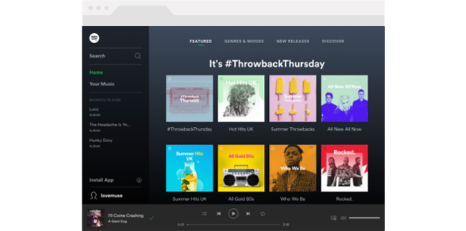

**Pic 6 – Home page example**

The web player is supported by the following web browsers:

* [**Chrome**](https://www.google.com/chrome/browser/desktop/index.html)
* [**Firefox**](https://www.mozilla.org/en-US/firefox/new/)
* [**Edge**](https://www.microsoft.com/en-us/download/details.aspx?id=48126)
* [**Opera**](http://www.opera.com/download)

# YOUR LIBRARY

Your Library is a catalog of all your saved artists, albums, songs, podcasts, and more!

## **Where is Your Library?**

* **Desktop and web player** – FindYour Library in the menu on the left.
* **Mobile and tablet** – Find Your Library at the bottom of the app

## **How do I save to Your Library?**

**Desktop and web player:**

For Albums, go to any album and **select** SAVE.

For Songs, **select** https://spotifysupport.freetls.fastly.net/article-gallery/articles2/inline_icons/icon_plus.png on any song.

For Artists, Podcasts, Videos, Radio stations, and Playlists, go to any and **select** FOLLOW.

**Mobile and tablet:**

If you’re using the free, ad-supported service on mobile, **tap** https://spotifysupport.freetls.fastly.net/article-gallery/articles2/inline_icons/icon_heart.png by a song, artist, album, or podcast to save it to **Your Library**. Songs you've liked appear in your **Favorite Songs**, under **Playlists**.

### Got Premium?

* For **Albums**, go to any album and **select** **SAVE**.
* For **Songs**, **select** https://spotifysupport.freetls.fastly.net/article-gallery/articles2/inline_icons/icon_plus.png on any song.
* For **Artists**, **Podcasts**, **Videos**, **Radio** stations, and **Playlists**, go to any and **select** **FOLLOW**.

# HOW TO PLAY

# To play great music, podcasts, and more on Spotify, all you need is [the app](https://support.spotify.com/article/download-the-spotify-player/), or go to our [web player](http://play.spotify.com/).

## **Desktop**

1. Open Spotify on the desktopapp or webplayer.
2. Use Search to find what you want.
3. Play any one of these ways:

* Hover your cursor over a track and **click** the Play https://spotifysupport.freetls.fastly.net/article-gallery/articles2/inline_icons/icon_play.png button on the left.
* **Double-click** a track name.
* **Click** an album or playlist in **Browse**.
* **Click** the green **PLAY** button below an artist, album, or playlist title. **Click** again to **PAUSE**.

### **Mobile & Tablet**

1. Open Spotify.
2. Use Search to find what you want.
3. Play either of these ways:

* To play in the order listed in the app: **Tap** an artist, album, or playlist, then **tap** the first song you want to hear.
* To shuffle the track listing: **Tap** an artist, album, or playlist, then **tap** **SHUFFLE PLAY**.

## **Control your listening with Now Playing**

After you start playing your music, control it with the Now Playing bar at the bottom of the app. On mobile devices, find it just above the menu bar and tap it for a bigger view and more controls.

* https://spotifysupport.freetls.fastly.net/article-gallery/articles2/inline_icons/icon_play.pnghttps://spotifysupport.freetls.fastly.net/article-gallery/articles2/inline_icons/icon_pause.png Play / Pause.
* https://spotifysupport.freetls.fastly.net/article-gallery/articles2/inline_icons/icon_previous.pnghttps://spotifysupport.freetls.fastly.net/article-gallery/articles2/inline_icons/icon_next.pngPrevious / Skip.
* https://spotifysupport.freetls.fastly.net/article-gallery/articles2/inline_icons/icon_heart.pnghttps://spotifysupport.freetls.fastly.net/article-gallery/articles2/inline_icons/icon_no.pngLike / Dislike. We use this to give you better recommendations. Also, when you like something, the song saves to **Your Library**.
* **[https://spotifysupport.freetls.fastly.net/article-gallery/articles2/inline_icons/icon_shuffle.png](https://support.spotify.com/article/shuffle/) Shuffle**.
* https://spotifysupport.freetls.fastly.net/article-gallery/articles2/inline_icons/icon_repeat.png Repeat album or playlist. Select again for
* https://spotifysupport.freetls.fastly.net/article-gallery/articles2/inline_icons/icon_repeat_one.png, to repeat song once. Select a third time to stop repeating.
* https://spotifysupport.freetls.fastly.net/article-gallery/articles2/inline_icons/icon_queue.png **Play Queue**.
* **[https://spotifysupport.freetls.fastly.net/article-gallery/articles2/inline_icons/icon_connect_device.png](https://support.spotify.com/article/spotify-connect/)** **Play to another device**.

# RESOURCES

* <https://support.spotify.com/lt/using_spotify/the_basics/>